Mammary gland
It is very important to know anatomical structure of mammary gland.. mammary gland common in all mammal and act as exocrine gland
External features:
It is 4 separate gland {quarter}
Fore represent 40% of the total size of the mammary gland
Hind represent 60% of the total size of the mammary gland
No interaction between quarters
Sometime there are accessory teat which may be
True accessory teat which secret milk or false teat there is no milk production
The presence of accessory teat 92% cranial ,5%between , 3 % caudal

Mammary gland structure:
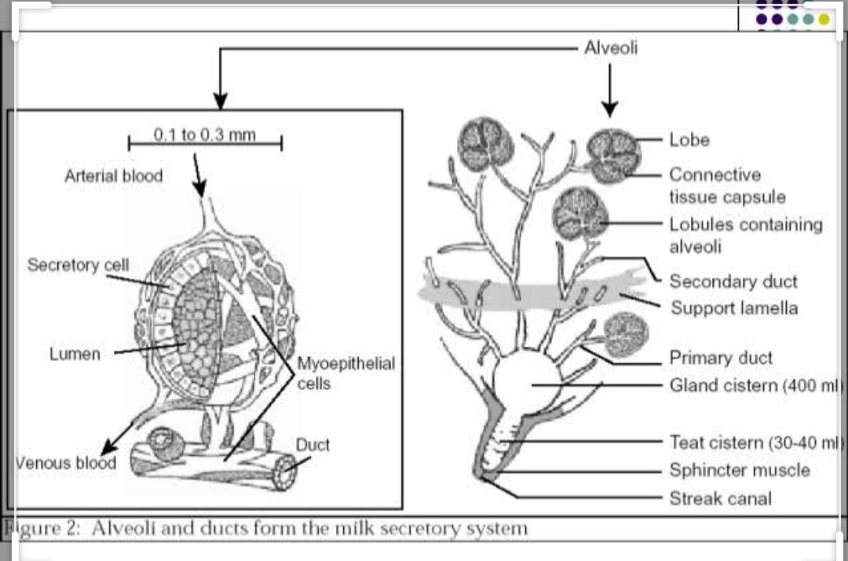 interior of the udder:
Gland cistern
100:400 ml milk storage
Ducts system drain into cistern
Used to detect the end of milking
Duct system
There is no secretory function
Alveoli
Milk producing unit
Secretory cell , myo epithelial cell , capillaries &duct
Lobule
150:200 alveoli ,common duct
Lobes
Group of lobule
Internal anatomy of the mammary gland
Streak canal {teat canal }
keep milk in udder & bacteria out the udder
teat cistern
duct in teat with capacity of 30:45 ml
seprate from streak canal by fold of skin called furstens berg
gland cistern
separate from teat cistern by cricoid fold
hold up to 400 ml of milk
it is the collecting area for the mammary ducts
Lobes
Group of lobule

lymphatic drainage
mammary LN {superfacsial inguinal}
sub iliac LN {prefemoral}
ischial LN
udder defence mechanism:-
non specific barrier of in fection {1st line of defense}
specific defence mechanism {2nd line of defense}
1st line of defense
1} three mechanical barriers to inhibit microbial infection of udder
- teat skin
- keratin plug that seals teat duct of dry cow
- teat sphincter
2}glandular secretion of milk contain several non specific bacterial inhibitor
- lactoferrine
- lacto peroxidase
- immune globuline
- macrophage

Second line of defense
1} the cellular immuneresponce in case of itra mammary infection{IMI} involves 3 type of leukocyte
A} macrophage
Normal present in milk of healthy cow
Making up 20000:40000 of SCC
B} neutrophils
Inducible WBCs
Increase massively in response to IMI
Kill bacteria by phagocytosis
Postpartum decrease neutrophils function e.g. mastitis , metritis & RP
C} lymphocytes
Present in low number in healthy udder and increase when inflammation occure
Structural defense of teat
Keratin plug
Sphincter muscle
Length and diameter of teat canal
Epithelium impermeable
Leucocyte in the fore milk

Milk synthesis
Water , vitamin & mineral
Secreted from arterial blood
Lactose
Manufactured in alveolar cell
Protein
90% manufactured in alveolar cell
Some passage from blood
Fat
75% manufacture in alveolar cell
Milk letdown
Evacuation of milk from alveolar lumen to duct system.

Milk ejection reflex
Pressure on sensitive receptor on teat cause feedback to supra optic &paraventricular nucli .
Stimulation of these neuron cause stimulation of the posterior pituitary which in turn release oxytocin hormone
Oxytocin cause myoepithelial cell to contract
Timing of stimulation important to milk flaw rate
Adrenaline block letdown by
Decrease milk blood flow
Decrease oxytocin release
Decrease myoepithelial response
Inhibition of milk ejection reflex {how cow hold up her milk }{effect of stress in milk}
Unusual circumstances such as physical pain &fear ,uses of milking machine such as in adequate udder preparation affect on sensory input which in turn reflect on posterior pituatry resulting in inhibition of oxytocin hormone .
Adrenal gland secrets Adrenaline which released in blood
Adrenaline cause contraction of the blood vessels and inhibition of myoepithelial contraction
Milk remain trapped in the lumen of alveoli
Hormonal impact on lactation :
1} prolactine
Source: AP
Effect :initiate lactogenesis
2} somatotropine
Source :AP
Effect:influence growth rate of the gland and increase milk production
3} thyroid hormone
Source: thyroid gland
Effect:influence milk production by regulation rate of metabolic process
4} parathyroid hormone
Sources: parathyroid gland
Effect: regulate blood Ca &P related to milk fever
5}adrenal hormone
Sorce: adrenal gland
Effect : in small amount nesseccary for milk production
In large amount during stress counter productive
6} oxtocin hormone
Source : PP
Effect :contraction of myoepithelial cell for milk letdown
7} placental lactogen
Source: placenta
Effect : influence prolactine &growth hormone
8} insulin hormone
Source : pancreas
Effect : move glucose through membrane for milk synthesis
Factors affect on milk production
1} inheritance
2}stage of lactation
3} pregnancy
4}age
5}frequency of milking
6}estrous
7}dry period
8}body condition
9}environment
10}feeds
11}proper preparation at milking time
12}stress
Normal cessation of production :
As lactation cycle proceed alveolar cell are lost normally
Eventually an animal ceases milk production
Drying off can be enhanced by
Cessation of milking and nursing
Reduction of caloric in food

Dry period
It is period of non lactation between subsequent lactation
Necessary for optimum life time of production
Reason for allowing cow to dry off
- To counter drop of milk yield that naturally occur at about 255 days carried calf
- To allow lactating udder to regenerate
- To allow rumen to recover from high concentrate diet fed durin lactation
- To treat chronic or persistent mastitis
During the first 10 :14 day of dry period,the following change can increase susceptablity to IMI
- Cessation of milk flow eliminating flushingeffect that physical remove M.os from teat canal
- Increased internal pressure in udder when milking is stoped ,making it is easier for bacteria to enter
- Reduced phagocytic activity inside udder
-Gradual formation of keratin plug increase occurance of IMI during dry period
During middle of dry period susceptablity to IMI infection decline as aresult of
Decreased IM pressure -
-Complet formation of keratin plug in the teat canal
-Increased concentration of leukocyte and other local immune factor

During last 10 :14 days as calving approaches susceptablity to IMI increase due to
Possible loss of keratine plug
Fluid accumulation in the udder causing leakage and allowing entery of bacteria
Impaired neutrophil function associated with prepartum physiologic stress
Reduced concentration of local immune factor
Accumulation of colostrum which interfere with leukocyte function

thanks

